select * from salesman

select * from customer

select * from orders

--1 salesperson and customer who reside in the same city

select s.salesman_id, c.customer_id, c.city as [customer_city] from

salesman s inner join customer c

on s.salesman_id = c.salesman_id

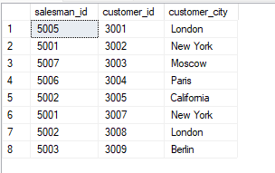

--2 orders where the order amount exists between 500 and 2000

select o.ord_no, o.purch_amt, c.cust_name, c.city as [customer_city] from

orders o inner join customer c

on o.customer_id = c.customer_id

where o.purch_amt between 500 and 2000

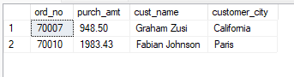

--3 salesperson(s) and the customer(s) he represents

select c.cust_name, c.city as [customer_city], s.name as [salesman_name], s.commission from

salesman s inner join customer c

on s.salesman_id = c.salesman_id

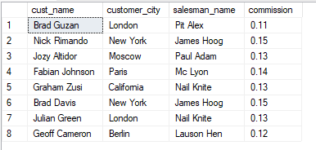

--4 salespeople who received commissions of more than 12 percent from the company

select c.cust_name, c.city as [customer_city], s.name as [salesman_name], s.commission from

salesman s left join customer c

on s.salesman_id = c.salesman_id

where s.commission > 0.12

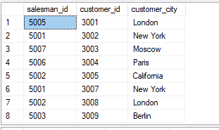

--5 salespeople who do not live in the same city where their customers live and have received a commission of more than 12% from the company

select c.cust_name, c.city as [customer_city], s.name as [salesman_name], s.city as [salesman_city], s.commission from

salesman s inner join customer c

on s.salesman_id = c.salesman_id

where c.city != s.city and s.commission > 0.12

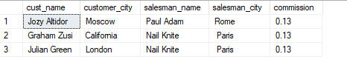

--6 details of an order

select o.ord_no, o.ord_date, o.purch_amt, c.cust_name, c.grade, s.name as [salesman_name], s.commission from

orders o left join

(customer c left join salesman s

on c.salesman_id = s.salesman_id)

on o.customer_id = c.customer_id

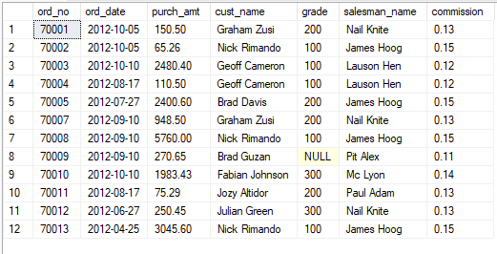

--7 same column of each table appears once and only the relational rows are returned

select c.customer_id, c.cust_name, c.city as [customer_city], c.grade, s.salesman_id, s.name as [salesman_name],

s.city as [salesman_city], s.commission, o.ord_no, o.purch_amt, o.ord_date from

orders o left join

(customer c left join salesman s

on c.salesman_id = s.salesman_id)

on o.customer_id = c.customer_id

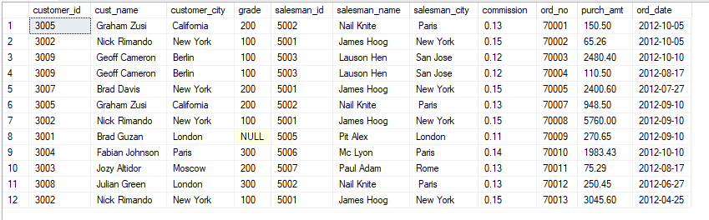

--8 ascending customer_id

select c.cust_name, c.city as [customer_city], c.grade, s.name as [salesman_name], s.city as [salesman_city] from

customer c left join salesman s

on c.salesman_id = s.salesman_id

order by c.customer_id asc

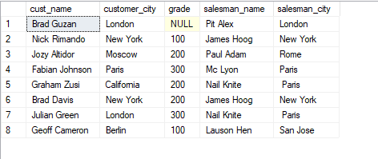

--9 customers with a grade less than 300

select c.cust_name, c.city as [customer_city], c.grade, s.name as [salesman_name], s.city as [salesman_city] from

customer c left join salesman s

on c.salesman_id = s.salesman_id

where c.grade < 300

order by c.customer_id asc

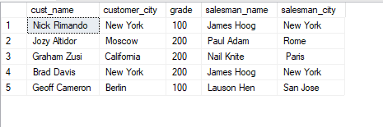

--10 determine whether any of the existing customers have placed an order or not

select c.cust_name, c.city, o.ord_no, o.ord_date, o.purch_amt from

customer c left join orders o

on c.customer_id = o.customer_id

order by ord_date asc

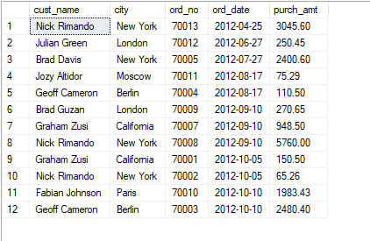

--11 determine if any of the existing customers have not placed orders or if they have placed orders through their salesman or by themselves

select c.cust_name, c.city as [customer_city], o.ord_no, o.ord_date, o.purch_amt, s.name as [salesman_name], s.commission

from ((customer c left join salesman s

on c.salesman_id = s.salesman_id)

left join orders o

on o.customer_id = c.customer_id)

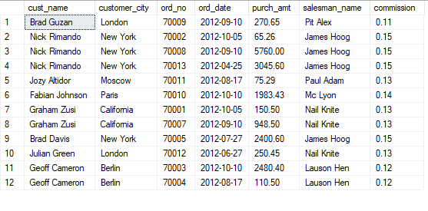

--12 of salespersons who work either for one or more customers or have not yet joined any of the customers

select s.salesman_id as [salesman_id], count(*) as [customers_served] from

salesman s left join customer c

on s.salesman_id = c.salesman_id

group by s.salesman_id

order by customers_served

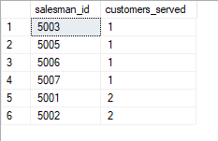

--13 list all salespersons

select c.cust_name, c.city as [customer_city], c.grade, o.ord_no, o.purch_amt, o.ord_date, s.salesman_id, s.name as [salesman_name]

from salesman s left join

(customer c left join orders o

on c.customer_id = o.customer_id)

on s.salesman_id = c.salesman_id

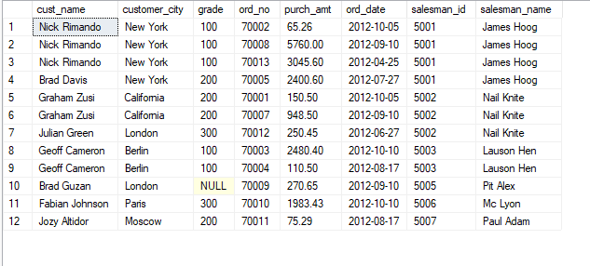

--14 salesmen who either work for one or more customers or yet to join any of the customers. The customer may have placed, either one or more orders on or above order amount 2000 and must have a grade, or he may not have placed any order to the associated supplier.

select s.name as [salesman_name], c.cust_name, c.grade, o.ord_no, o.ord_date, o.purch_amt from

salesman s left join

(customer c left join orders o

on c.customer_id = o.customer_id)

on s.salesman_id = c.salesman_id

where o.purch_amt >= 2000 and c.grade is not NULL

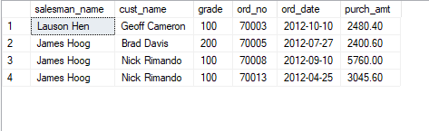

--15

select s.name as [salesman_name], c.cust_name, c.grade, o.ord_no, o.ord_date, o.purch_amt from

salesman s left join

(customer c left join orders o

on c.customer_id = o.customer_id)

on s.salesman_id = c.salesman_id

where o.purch_amt >= 2000 and c.grade is not NULL

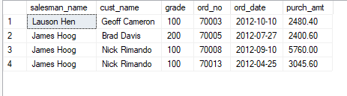

--16 customers on the list who must have a grade and placed one or more orders or which order(s) have been placed by the customer who neither is on the list nor has a grade.

select c.cust_name, c.city as [customer_city], o.ord_no, o.ord_date, o.purch_amt from

customer c inner join orders o

on c.customer_id = o.customer_id

where c.grade is not NULL

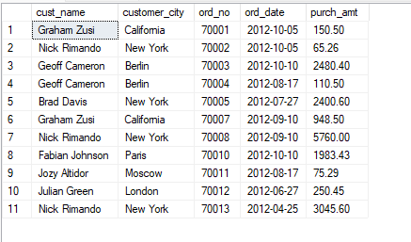

--17 combine each row of the salesman table with each row of the customer table

select * from

salesman cross join customer

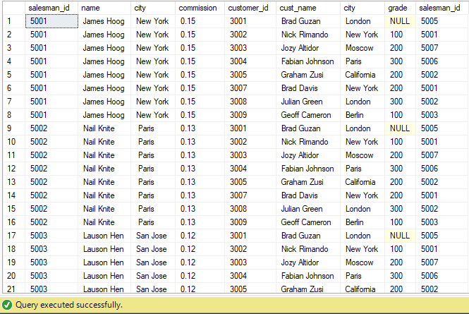

--18 each salesperson will appear for all customers and vice versa for that salesperson who belongs to that city

select s.salesman_id, c.customer_id, c.city from

salesman s cross join customer c

where s.city = c.city

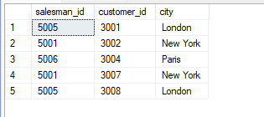

--19 each salesperson will appear for every customer and vice versa for those salesmen who belong to a city and customers who require a grade

select * from

salesman s cross join customer c

where s.city is not NULL and c.grade is null

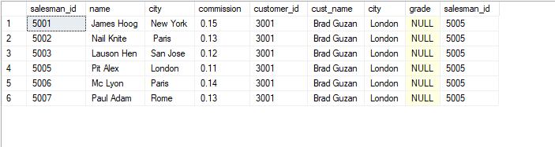

--20 each salesman will appear for all customers and vice versa for those salesmen who must belong to a city which is not the same as his customer and the customers should have their own grade

select * from

salesman s cross join customer c

where s.city is not NULL and s.city != c.city and c.grade is not null

